Building a Maven Project with Jenkins

This section will guide you to:

* Install Maven and create a Maven project
* Create a Jenkins build job to build a Maven project
* Build a Maven project in Jenkins

**Step 1:Install Maven and create a Maven project**

* Open the terminal.
* If you do not have Maven installed already, run the command, ***sudo apt-get install maven***
* Run the command **mvn --version** to verify the installation.
* Run the following command to create a Maven project:

**mvn archetype:generate -DgroupId=com.simplilearn.app**

**-DartifactId=url-check -DarchetypeArtifactId=maven-archetype-quickstart -DarchetypeVersion=1.4 -DinteractiveMode=false**

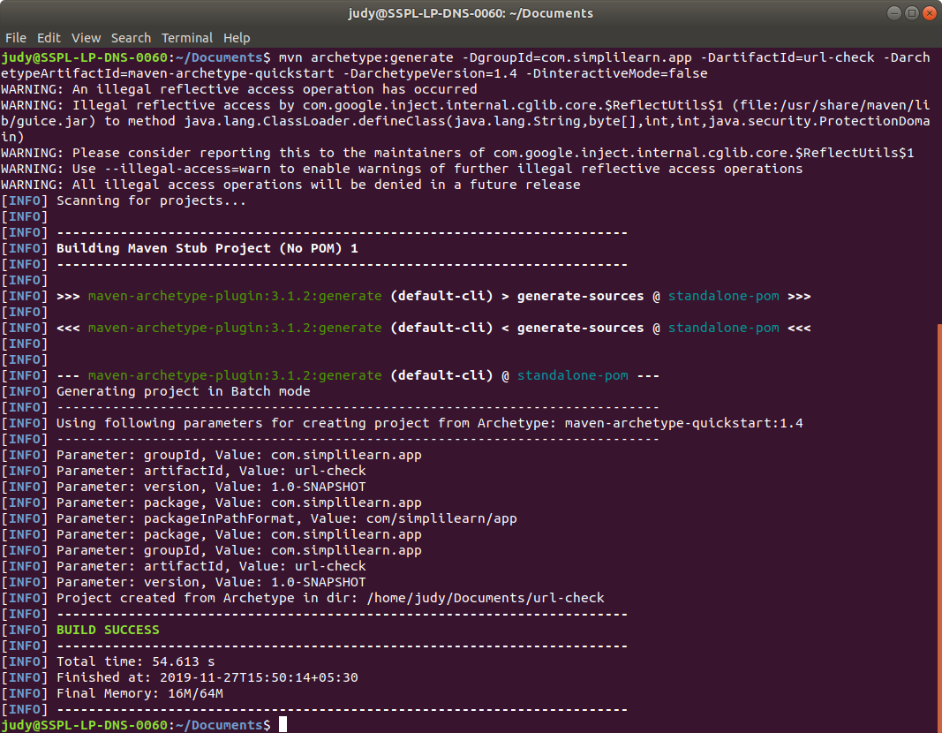

* Once the command is executed, run **cd url-check**
* Inside the project directory, run **ls** and find the***pom.xml*** file.
* Run **cd src/main/java/com/simplilearn/app**
* Open **App.java** in a text editor. Example: **vi App.java**
* Replace the contents with the below code and save it:

**package com.simplilearn.app;**

**import java.io.IOException;**

**import java.net.HttpURLConnection;**

**import java.net.URL;**

**public class App{**

**public static String checkResponse(String url) throws IOException{**

**HttpURLConnection connection = (HttpURLConnection) new URL(url).openConnection();**

**connection.setRequestMethod("HEAD");**

**int responseCode = connection.getResponseCode();**

**String response = "Success";**

**if (responseCode != 200) {**

**response = "Failed";**

**}**

**return response;**

**}**

**public static void main(String[] args) throws IOException{**

**System.out.println(checkResponse("https:/"+"/samples.openweathermap.org/data/2.5/weather?q=London,uk&appid=b6907d289e10d714a6e88b30761fae22"));**

**}**

**}**

**Step 2: Create a Jenkins build job to build a Maven project**

* Click on ***New Item*** in the Jenkins dashboard.
* Enter a **name** for your Maven project.
* Select ***Maven Project*** as the build job type.

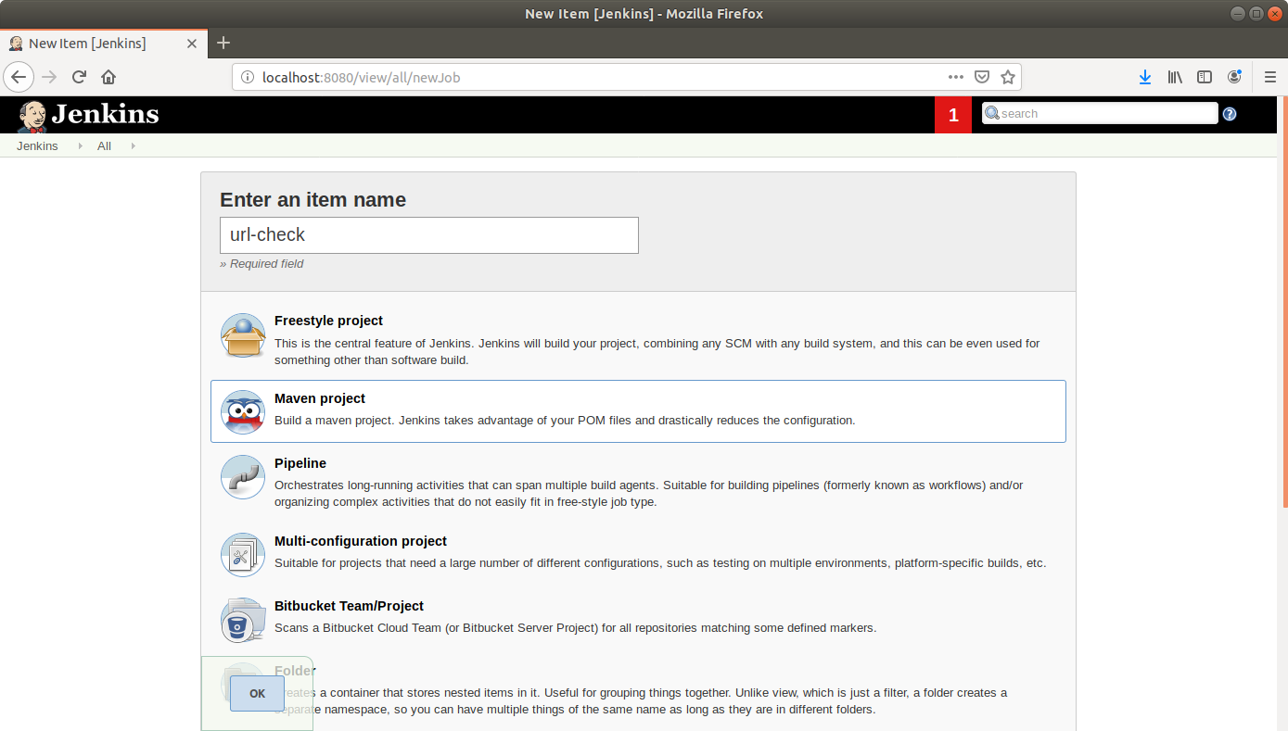

* Click ***OK***.
* Keep the defaults and scroll down to the ***Build*** section.
* Enter the path to the **pom.xml**.

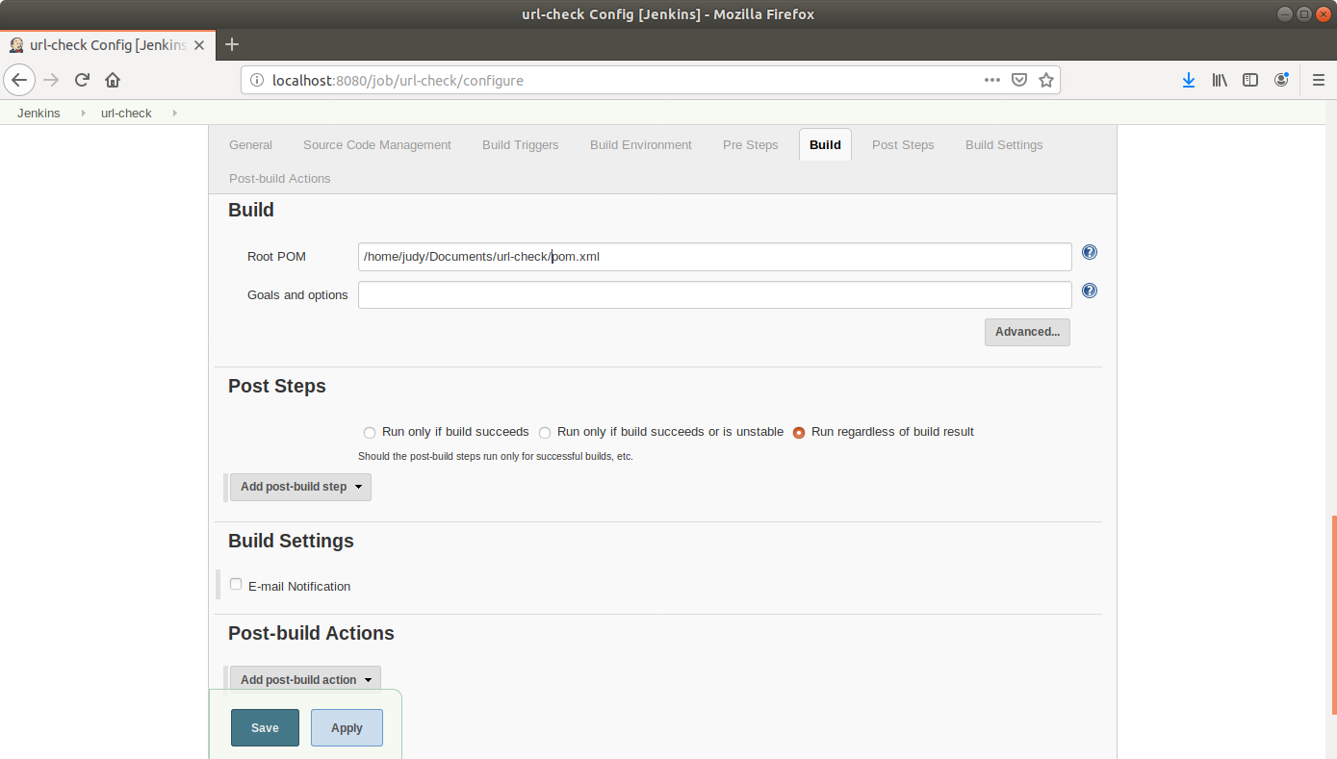

* Scroll down to the *Post-build Steps* section.
* Click on ***Add post-build step*** and choose ***Execute shell*** from the drop down menu.
* Enter the following commands in the command section:  
    
  **cd /*home/*labuser/url-check/**

**mvn clean**

**mvn package**

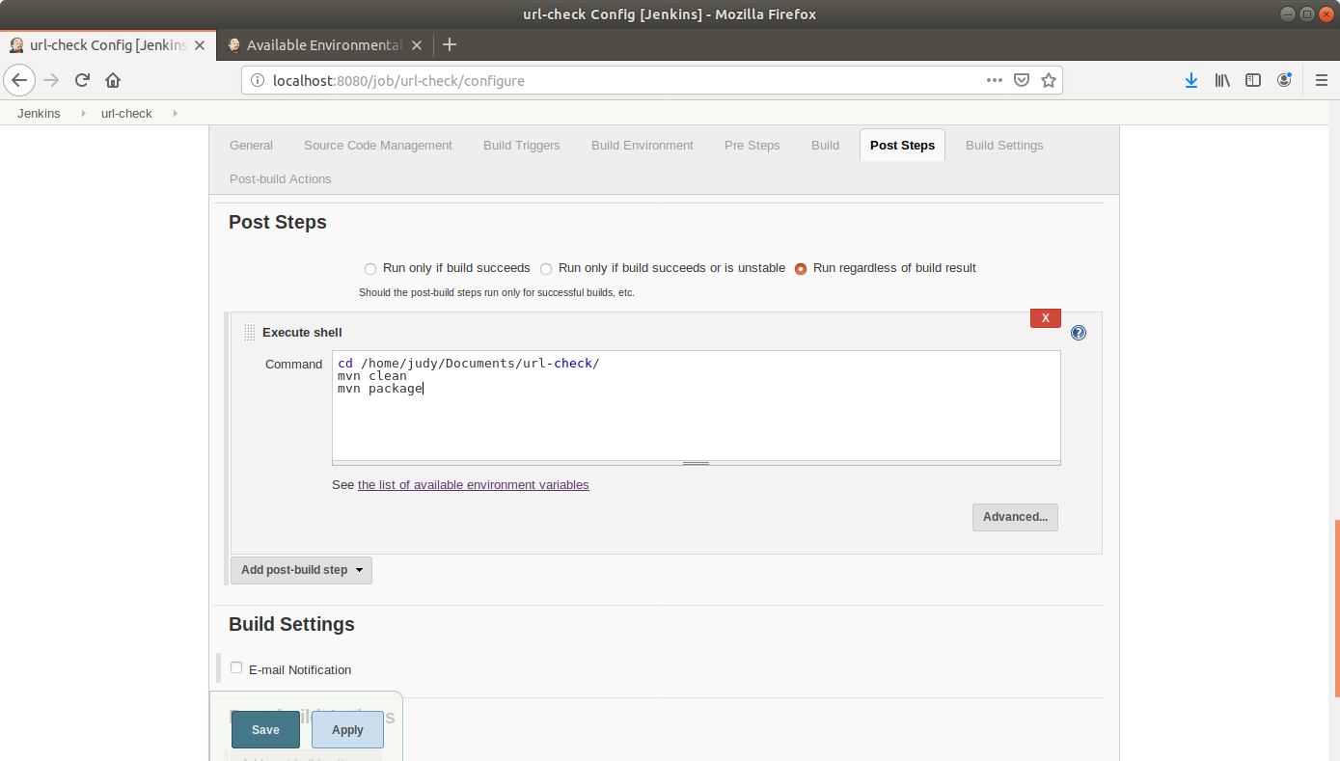

* Click ***Save***.

**Step 2.4.3:** Building a Maven project in Jenkins

* Click on the project name in the Jenkins **dashboard**.
* Click ***Build Now*** in the project window. Jenkins will now build your project.

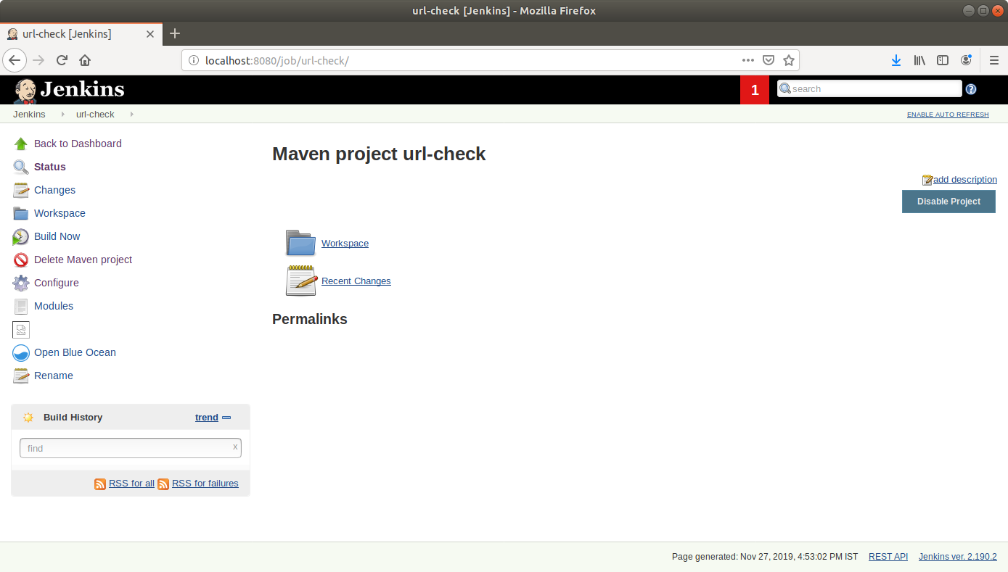

* Click on the ***Build History***to view the build results.
* Click on the ***Console Output*** to view the build logs.

